Name: _________________________________Class Period: _________

Unit 2: Nutrition & Fitness

You will need to bring this to class every day.
DO NOT LOSE THIS PACKET!

Mustanghealth.weebly.com

You must fill out the entire page to earn points each day. If you miss a bell ringer or portion of notes, you will earn zero points for the day.

_____ Nutrients – 5 pts.
_____ MyPlate – 5 pts.
_____ Healthy Food Choices – 5 pts.
_____ Components of Fitness – 5 pts.
_____ Body Image & Eating Disorders – 5 pts.

_________ Total points earned for unit 1 notes/bell ringers – 25 pts. possible

This packet is due on: _______________________________________

2.1 Nutrients

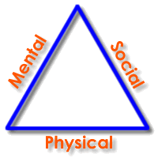
Bell Ringer #1: Using the triangle below, tell me how an unhealthy diet can affect all three areas of the health triangle?
_______________________________________________________________________________________________ _______________________________________________________________________________________________ _______________________________________________________________________________________________ _______________________________________________________________________________________________ _______________________________________________________________________________________________ _______________________________________________________________________________________________ _______________________________________________________________________________________________ _______________________________________________________________________________________________ _______________________________________________________________________________________________ _______________________________________________________________________________________________

- What are nutrients?
  - A substance that provides nourishment essential for growth.
  - Nutrient Dense: Foods that are _______________ in nutrients.
    - Examples: _____________________________________________________________________________________________
  - Empty Calories: Foods that are_______________ in calories, but _____________ in nutrients.
    - Examples: _____________________________________________________________________________________________
- Types of Nutrients
Nutrient | Why we need it | Types/Sources
#1- Carbohydrates |  | Fiber- Eliminates waste.  Sources
#2- Fats |  | Trans Fat - can lead to clogged arteries.  Sources  Saturated Fat - can lead to increased risk of stroke and heart disease.  Sources  Unsaturated Fat - can lead to a decreased risk of stroke and heart disease.  Sources
#3- Protein |  | Sources
#4- Vitamins |  | Sources
#5- Minerals |  | Sources
#6- Water |  | Sources

2.2 Food Groups and Portion Sizes
Bell Ringer #2: If you could ask for any meal, what would it be (You may list your response)?______________
__________________________________________________________________________________________________________________________________________________________________________________________________________________________________________________
__________________________________________________________________________________________________________________________________________________________________________________________________________________________________________________
- Fruits Group
  - Foods in this group: __________________________________________________________________________________________
__________________________________________________________________________________________________________________
  - How much do you need per day? ____________________________________________________________________________
- Vegetables Group
  - Foods in this group: __________________________________________________________________________________________
__________________________________________________________________________________________________________________
  - How much do you need per day? ____________________________________________________________________________
- Protein Group
  - Foods in this group: __________________________________________________________________________________________
__________________________________________________________________________________________________________________
  - How much do you need per day? ____________________________________________________________________________
- Grains Group
  - Foods in this group: __________________________________________________________________________________________
__________________________________________________________________________________________________________________
  - How much do you need per day? ____________________________________________________________________________
- Dairy Group
  - Foods in this group: __________________________________________________________________________________________
__________________________________________________________________________________________________________________
  - How much do you need per day? ____________________________________________________________________________
- Fats
  - Foods in this group: __________________________________________________________________________________________
__________________________________________________________________________________________________________________
  - How much do you need per day? ____________________________________________________________________________
- Serving Sizes
  - Baseball = ______________________________________________________________________________________________________
  - Deck of Cards = ________________________________________________________________________________________________
  - Golf Ball = ______________________________________________________________________________________________________

2.3 Healthy Food Choices
Bell Ringer #3: Look at the food label at the bottom of the page. Do you think this is a healthy or unhealthy product? Please explain your answer: ________________________________________________________________
__________________________________________________________________________________________________________________________________________________________________________________________________________________________________________________
- How to read food labels - http://kidshealth.org/en/parents/nutrition-label-video.html
  - #1 - What is the very first thing you should look at? _______________________________________________________
  - #2 - Calories are a measurement of what? Energy
    - What usually happens if we eat more calories than we burn? ____________________________________
    - What usually happens if we burn more calories than we eat? ____________________________________
  - #3 - Fat
    - Two types of bad fat? ________________________________________ ________________________________________
      - What do they increase your risk of? Heart Disease
    - Two types of good fat? _______________________________________ _______________________________________
      - These are good for your heart but still high in calories.
  - #4 - Carbohydrates
    - Types of carbs: ___________________________________________ ____________________________________________
      - Which should you get plenty of? ___________________________________________________________
      - Which should you eat in moderation? _____________________________________________________
  - #5 - Protein
    - Builds muscle, hair, and skin.
  - #6 - Vitamins and Minerals (below the back line)
  - #7 - % Daily Value (right side of the label)
    - Based on a 2,000 calorie diet.
    - Quick tips:
      - _________% or less = low
      - _________% - _________% = medium
      - _________% or more = high
    - Which nutrients do we want to be in the high and low levels? Write an “H” next to the ones we want high and an “L” next to the ones we want low.
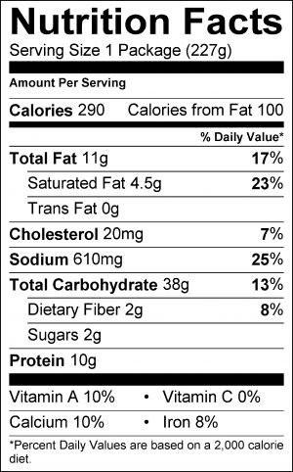

2.4 Elements of Fitness
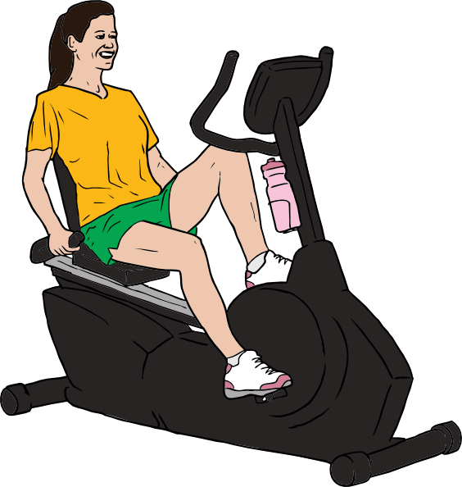
Bell Ringer #4: Look at the picture to the right. In what ways is she improving her physical health? ______________________________________________________
______________________________________________________________________________________________________________________________________________________________________________________
___________________________________________________________________________________________
___________________________________________________________________________________________
___________________________________________________________________________________________

- What does it mean to be physically fit?
  - It’s determined by the ability of the ______________________________, ______________________________, and ______________________________ systems to meet certain demands.

- Five Elements of Fitness
Element of Fitness | Definition | Activities that build this element/How it’s measured
#1 Cardiovascular Endurance | How efficiently your _____________ and ______________ work when you exercise and how quickly they return to normal when you stop.
#2 Muscular Endurance | A muscle’s ability to perform a ________________________________________ without fatiguing.
#3 Muscular Strength | The amount of _____________________ a muscle can exert, in a ________________ effort.
#4 Flexibility | The ability of your body’s joints to move easily through a ___________ _____________________________
#5 Body Composition | The ratio of __________________ to __________________________ (bone, muscle, & fluid)
- Fitness and a Healthy Attitude
  - What else determines level of fitness?
    - ______________________________: The passing of traits from parents to their children.
      - Example: _____________________ is a trait that is often passed down from parents.
    - _______________________________________________
    - Focus on what you can do!

2.5 Body Image & Eating Disorders

Bell Ringer #5:

Name | Body part affected | What it does to the body
Pulmonary Vascular  Disease |  | Affects the_________ vessels that go______ and _______ the lungs. Makes it more difficult to ___________________
Nonalcoholic fatty liver disease |  | Too much ________ gathers around the_______________, causing scars.
 | Blood vessels | Too much fat________________ the blood vessels going _________ and from the heart.
 |  | Happens when blood flow to part of the brain stops causing a “brain attack” Can cause cells in the brain to die, causing permanent damage.
Osteoarthritis | Joints
Diabetes | Pancreas | Type I-  Type II-
Hypertension |  | _____________________ high blood pressure. Overworks the _________________ and can lead to heart attack.
 | body
Think-Pair-Share
Think-On your own write ways obesity can affect your health triangle. MAKE SURe yoU GET ALL THREE! (physical, Mental/emotional and social).

Pair- with a partner share your thoughts. Combine your thoughts and be ready to share

Share your ideas with the class

