Kidshealth.org Assignment
The purpose of this assignment is to be an introduction to learning about male and female anatomy before our discussion/ activities in class on Wednesday.
You will go to the website: http://www.kidshealth.org/teen/
Select the button on the left side of the page titled Sexual Health.
Under the section titled “Your Changing Body” you will first select “Female Reproductive System” and answer the questions below:
- What is reproduction?

- The two types of sex cells or ______________ are involved in the reproductive process: The male gamete or __________ and the female gamete or ______________ meet in the female reproductive system.
- Humans pass certain characteristics of themselves to the next generation through their _________, the special carriers of human traits.
- Male and Female Reproductive systems are different in _________ and structure, but are designed to ___________, nourish and ____________ either the egg or sperm.
- The female reproductive system is located in the pelvis or the __________ part of the ______________.
- External Female reproductive organs include the __________ which means covering.
- The ___________ is a muscular hollow tube that extends from the vaginal opening to the ________. It is ____ to ____ inches long in a grown woman.
- The vagina has the ability to expand and __________, and allows it to accommodate something as slim as a tampon or as big as a baby.
- The __________ or womb, is shaped like an upside down pear with a thick lining and muscular walls.
- The ___________ connects the vagina and uterus and is very small (no wider than a straw). This part of the body expands to allow a baby to pass through.
- The ____________ tubes connect the uterus to the __________.
- The _____________ are two oval-shaped organs that lie to upper left and right of the uterus. They ___________, __________ and _______________ eggs (the female gamete).
- Ovaries also produce the female sex ______________ called ______________ and ________________.

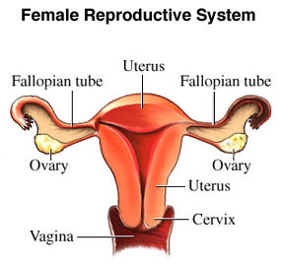
After filling in the guided notes for female reproduction, go back to the main “Sexual Health” page and under the “Your Changing Body” tab, select “Male Reproductive System” and fill in the following guided notes.
- The ____________ vesicles secrete a thick fluid that nourishes the ___________.
- The ____________ gland, is a walnut sized gland that surrounds a portion of the urethra and produces some fluid in the semen.
- The _______ __________ is a thin muscular tube that transports ________ from the epididymis to the urethra.
- The ___________ is a tube that caries semen and urine out of the penis.
- The ______________ hangs under the penis and contains the ___________ and ____________.
- The _____________ is the male external genitalia. It includes the _________ or the main part, the ___________ or the tip.
- The male sex hormone ______________ and the male gamete ___________ are produced in the ______________ or testes.
- This is the storage unit for the sperm created by the testes, also called the ___________________.
