Name_____________________________
Period___________
Unit 5: Human Sexuality

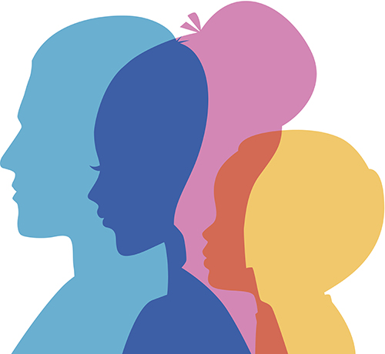

Day 1 Notes _____/15
Day 2 Notes _____/15
Kids Health.org assignment _____/25
Day 3 Notes_____/15
Day 4 Notes _____/15
Day 5 Notes _____/15
Position Paper _____/50

Total Points _______/150

Day 1: Changes during Adolescence

Writing Prompt:
Write your responses to the following questions:

What was one goal you had as a child?________________________________________________________.
What is one goal you have as a teenager_______________________________________________________.
What will be one goal you have as an adult?___________________________________________________.
Changes of You:
During puberty a lot of _____________ occur in your body.
Puberty: when your body begins to ________________ and _______________.
When does it occur?
During _______________________ or the teenage years between 13 and 19 and is considered the transitional change from ______________________ to _____________________________.
For Girls: Between _________ and __________ years old.
For Boys: Between _________ and __________ years old.
Although, some people start puberty a bit _____________________ and some, ________________.
What causes puberty to start?
When your body reaches a certain age, your brain releases a special __________________ that signals the start of puberty.

Physical Changes
In Boys
Shoulders grow _____________.
Voice becomes _______________.
Hair grows under the __________ and in the pubic areas.
__________ may appear
Odor (caused by a _______________ ____________ in the glands)

In Girls
Earliest change is usually breast ______________________.
Hips get wider
___________ may appear
Hair appears under the arms and in the pubic region.
_________________________ (period) starts.
For both ___________ and ________________, it usually takes several _____________ after the first changes of puberty begin before they are all complete- and there’s a lot of __________________ from person to person.
So, two normally developing guys or girls who are the same ________ can appear quite ________________ from each other.
Your brain changes too!
Adolescence is a time of significant growth and development inside the teenage brain.
The ______________________________ is the decision making part of the brain.
Responsible for:
Our ability to ___________ and ___________ about the consequences
_____________ problems.
And ________________ impulses.
Emotional Changes
You might feel ________________________ or have strong _____________________ that you’ve never experienced before. You may feel ____________________ about how your changing body looks.
Other emotional changes include:
- More interest in the ______________________ ___________.
- Learning to ___________________ and ____________________ your feelings.
- You start to feel differently about your __________, ______________________ and _____________________.
- Feel closer to your friends and feel less connected to your ___________________.
Handling emotions
One day you could feel angry, sad, happy, scared and excited. The next day you may feel gloomy enough to cry.
This is often caused by ______________________.
Lashing out at others or keeping feelings hidden inside--- not a good way to ________________ ______________.
Express your feelings by (write a few that you personally can do):

Social Changes
- Volunteering in _____________, sports teams, or special interest _______________.
- The social connections that you make as a teen can help you develop friendships, find job opportunities and get ______________________ support.
- These connections also shape your values, and help you discover ________ ________ _______.

Things to remember
Does every teen develop at the same time or even in the same way? _____________
Are you “normal” if you develop earlier or later than your peers?

Kidshealth.org Assignment
The purpose of this assignment is to be an introduction to learning about male and female anatomy before our discussion/ activities in class on Wednesday.
You will go to the website: http://www.kidshealth.org/teen/
Select the button on the left side of the page titled Sexual Health.
Under the section titled “Your Changing Body” you will first select “Female Reproductive System” and answer the questions below:
- What is reproduction?

- The two types of sex cells or ______________ are involved in the reproductive process: The male gamete or __________ and the female gamete or ______________ meet in the female reproductive system.
- Humans pass certain characteristics of themselves to the next generation through their _________, the special carriers of human traits.
- Male and Female Reproductive systems are different in _________ and structure, but are designed to ___________, nourish and ____________ either the egg or sperm.
- The female reproductive system is located in the pelvis or the __________ part of the ______________.
- External Female reproductive organs include the __________ which means covering.
- The ___________ is a muscular hollow tube that extends from the vaginal opening to the ________. It is ____ to ____ inches long in a grown woman.
- The vagina has the ability to expand and __________, and allows it to accommodate something as slim as a tampon or as big as a baby.
- The __________ or womb, is shaped like an upside down pear with a thick lining and muscular walls.
- The ___________ connects the vagina and uterus and is very small (no wider than a straw). This part of the body expands to allow a baby to pass through.
- The ____________ tubes connect the uterus to the __________.
- The _____________ are two oval-shaped organs that lie to upper left and right of the uterus. They ___________, __________ and _______________ eggs (the female gamete).
- Ovaries also produce the female sex ______________ called ______________ and ________________.

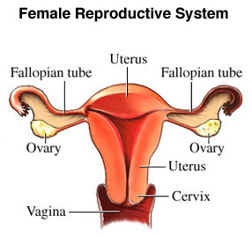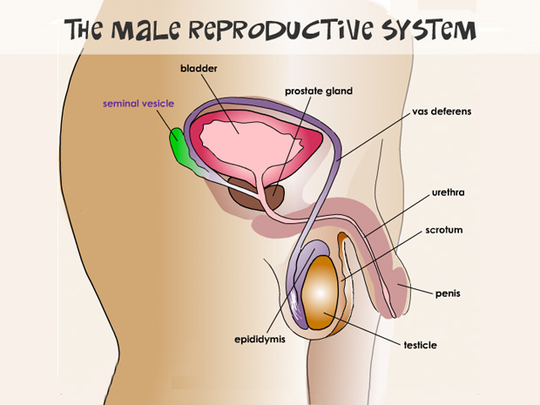
After filling in the guided notes for female reproduction, go back to the main “Sexual Health” page and under the “Your Changing Body” tab, select “Male Reproductive System” and fill in the following guided notes.
- The ____________ vesicles secrete a thick fluid that nourishes the ___________.
- The ____________ gland, is a walnut sized gland that surrounds a portion of the urethra and produces some fluid in the semen.
- The _______ __________ is a thin muscular tube that transports ________ from the epididymis to the urethra.
- The ___________ is a tube that caries semen and urine out of the penis.
- The ______________ hangs under the penis and contains the ___________ and ____________.
- The _____________ is the male external genitalia. It includes the _________ or the main part, the ___________ or the tip.
- The male sex hormone ______________ and the male gamete ___________ are produced in the ______________ or testes.
- This is the storage unit for the sperm created by the testes, also called the ___________________.

Day 2: Female and Male Reproductive Anatomy and Communication Part 1
Writing Prompt:
How does growing older and maturing have an impact on your relationships?
Brainstorm and write at least three bullet points.

Female and Male Reproductive Anatomy Review
Respect for human sexuality is dependent in part upon a ______________ understanding of ______________, physiology, and the growth and ________________ of the reproductive systems.
Caring for the reproductive system is _____________________ to maintaining a healthy life.
There is a need for _________________, responsible behavior with respect to reproduction.
It is important for you to understand how your body functions. ______________ of information can contribute to ________________ behavior that can have a devastating effect.
Female Reproductive Anatomy: Process of Menstruation
________________ secretion cause an __________ in the ____________ to mature.
About ____________ a month, that tiny eggs leaves the ovaries (_____________________) and travels down one of the ______________________ tubes.
Before ovulation, hormones stimulate the __________________ to build up the lining with extra blood and _______________.. This happens to prepare the uterus for ____________________.
If the egg isn’t _________________________ (sperm meets egg) the egg will not attach to the wall of th uterus, and the uterus sheds the extra tissue lining.
The blood, _______________ and unfertilized egg, leave the uterus going through the vagina on the way out of the body. This is the _______________ ________________.
This process happens almost every month for several decades (except of course, when a ____________ is pregnant) until the woman reaches _______________________ and no longer releases eggs from her ovaries.
Irregular periods are ___________________ in girls who are just beginning to menstruate. It may take the body a while to sort out all the changes going on.
Male Anatomy
Even a _____________ injury to the testicles can cause severe _____________, bruising or swelling. Most testicular injuries occur when the testicles are ______________, hit, kicked or _________________.
Men are often unaware of the need for regular _____________-____________________ and ________________ physician’s examinations. Beginning at ______________, with the enlargement of the testicles, every boy and man should examine his testicles ____________ a month. Any changes in size or ________________ of the scrotum of testicles requires immediate medical attention.
Dating/Relationships and Communication
What are qualities that define a romantic relationship?
What boys want/ What girls want Activity:
Characteristics of a Healthy Relationship
Honesty and Trust:
- Giving real compliments
- Discussing ______________.
- Using “I” Messages to share feelings
- Admitting _________________.
- Asking (not accusing) each other about rumors
Emotional Respect:
- Disagreeing without put-downs or threats
- Respecting their right to be _____________ and to control their own bodies and decisions
- Caring to find out their point of view.
Listening:
- Asking what they __________ and how they _______________.
- Empathize by putting yourself in their shoes
- Saying what we think we heard to check for understanding
- Asking what is important to them.
Freedom and Encouragement
- We have the right to our own and support each other’s rights to have ____________, feelings, space, activities, friends, and dreams
- Expressing fears, instead of claiming ownership when jealous
- Either person can decide to ___________________.

What are ways you can develop and maintain a healthy relationship based on characteristics we have discussed?
________________________________________________________________________________________________________________________________________________________________________________________________________________________________________________________________________________________________________________________________________________________________________________________________________________________________________________________________
Ways to Strengthen Relationships
- Be aware of what you want for yourself and for your relationship
- Let one another know what your ___________ are and be able to __________________ them assertively
- Do not demand that a partner change to meet all of your expectations
- Realize that healthy relationships take continual ____________ and _______________ to maintain.
Dating Purpose
To meet new people
To have new _____________ experiences
______________________
Find out what qualities you like and _______________.
Dating Age depends on: When you are socially/mentally/ emotionally ___________ and when your ___________ let you.
Things to consider when choosing a date:
________________ values and standards
Parents approve
Close to your ________ age
More than ___________ attraction
Communication
It is a _______________ component to any relationship
Appropriate ways to show affection:
- Showing _________________ for their personal space and ________________________.
- Complimenting and showing interest, not criticizing and belittling.
- Respecting their right to be safe and to control their own bodies and decisions.

Day 3
Writing Prompt:
Think of relationships you have seen in movies and TV shows or in your own life that show healthy and unhealthy characteristics. On the T-chart below, list the characteristics of healthy relationships and the characteristics of unhealthy relationships.
Healthy Relationships Unhealthy Relationships

Communication Continuum:
Less healthy--------------Healthy----------------Less healthy
Passive Behaviors/Style | Assertive Behaviors/Style | Aggressive Behaviors/Style
Hoping the other person will guess your feelings | Using “I” messages to explain your feelings | Using “you” messages to blame the other person
Always listening; rarely talking | Actively listening to the other person | Interrupting; being sarcastic
Denying your own feelings | Trying to understand the other person’s feelings | Making fun of the other person’s feelings; using name calling
Criticizing yourself; always apologizing | Expressing appreciation, being respectful | Criticizing the other person, never giving a complement
Always giving in to the other person | Seeking a compromise that does not go against either of your values | Always wanting your own way
Mumbling; looking away; fidgeting nervously | Speaking clearly and confidently; making eye contact; appearing interested | Yelling or refusing to talk; pointing your finger; glaring; using physical force.

Below, CIRCLE if the scenarios are passive, assertive, or aggressive communication styles. If they are passive or aggressive, rewrite those scenarios using an assertive communication style.
1. Passive, Aggressive or Assertive: Sam wants to try out for the men’s basketball team. His parents think that he should focus on school work and just play basketball for fun, insisting that basketball will take too much time. Sam refuses to talk to his parents, determined that they are just being unfair, and he will try out for the basketball team anyway.

2. Passive, Aggressive or Assertive: Rebecca has made the decision to wait until after marriage to have sex. Her boyfriend, Shawn, has been pressuring her to have sex, saying that if they are in love, why should they wait? Every time they talk about it, Rebecca gets very nervous and hopes Shawn will see her nervousness and stop asking her.
_____________________________________________________________________________

3. Passive, Aggressive or Assertive: Shelby has a lot of friends that like to joke about sexual topics that make Shelby feel very uncomfortable. She feels very anxious when she knows they are going to hang out. Shelby decides to talk to her friends the next time they meet and tell her that the conversations make her feel uncomfortable and to ask her friends to please not joke about those things around her.
____________________________________________________________________________
4. Passive, Aggressive or Assertive: Tom and his friends like to hang out a lot after school. He knows his friend Robert has made a choice to remain sexually abstinent until marriage. Tom constantly makes fun of Robert for his choice to remain abstinent. Robert is a little shy, and not sure how to defend his choice, always looking away when Tom says hurtful things about him.
____________________________________________________________________________
5. Passive, Aggressive or Assertive: Jill and her boyfriend Jared have talked a lot about open communication in their relationship. They have decided that if one of them ever feels uncomfortable, that they immediately tell the other person and they will listen and discuss the issue. This has created a lot of opportunities for Jill and Jared to strengthen their relationship and have open, respectful discussions.
_____________________________________________________________________________

Reflection Questions

What are the benefits of becoming more assertive in our communication style and expression of emotion?

Why is important to use assertive communication when clarifying your values or what you believe in if someone tries to get you to do something you do not want to do?

What goals can you set this week to become more assertive in your communication style?

Inappropriate Comments/Advances:
People we _________, or even people we don’t know could make _______________comments or advances that could make you feel uncomfortable.
Knowing what to do _____________ will help you avoid or leave situations like this if they happen.

HOW TO SAY NO
1. Just say no.
"I'd rather not."
2. Ignore the comment.
Appear not to hear, or act too busy.
3. Make an excuse.
"I'm tired."
4. Change the subject.
"Isn't it time for dinner."
5. Turn the idea into a joke.
"How could you suggest such a thing when you know I'm
on a diet."
6. Act surprised.
"You've got to be kidding!"
7. Express your feelings for them.
"Sorry, but I like you too much to do that."
8. Suggest a different plan.
"Let's go to my house and make a pizza."
9. Return the challenge.
"If you really liked me you'd never ask me to do that."
10. Leave.
"Go home."

Dating Rules Poster
Below, list your dating rules that you have, or that your parents have for your family. Discuss them with your parents. Be sure to get them to sign it!

For Parents:
I have discussed the following with my student (signature) _________________________________________
Thank you!
Day 4
Writing Prompt
Below, rank the following in order of importance (1- Most, 5- Important but not too crazy, 10- Not really on my mind yet)
Ranking
- Spending time with friends
- Finishing High School
- Getting a job
- Having your parent’s approval
- Living according to personal or family beliefs
- Traveling
- Being Healthy
- Getting Good Grades
- Making a Sports team or Music Group
- Going to College
Reflection:___________________________________________________________________________________________________________________________________________________________________________________________________________________________________________________________________________________________________________________________________________________________________________________________________________________________________________________________________________________________________________________________________________________

(Notes on Next Page)

Family Planning Worksheet
Budget for December
Wages after Tax/Total Income | $
Money into Savings | $
Food (for the month) | $
Mortgage or Rent | $
Utilities (water, electricity, gas, garbage) | $
Transportation (car payments, gas) | $
Loan repayment | $
Insurance | $
Clothing | $
Diapers/Formula | $
Lessons, Soccer Practice, Etc | $
Date Money | $

Reflection:
How hard was it to budget your money? (circle one)
Extremely Hard Very Hard Hard Somewhat Hard Not Hard
Why?
________________________________________________________________________________________________________________________________________________________________________________________________________________________________________________________________________________________________________________________________________________________________________

How would budgeting change as a teen parent? Would it be harder to budget? Why or why not?
________________________________________________________________________________________________________________________________________________________________________________________________________________________________________________________________________________________________________________________________________________________________________

Benefits of Remaining Sexually Abstinent Before Marriage
Emotional Benefits:

Physical Benefits:

NewBorn Safe Haven Law:
What is it?
____________________________________________________________________________________________________________________________________________________________________________________

What does it do?
____________________________________________________________________________________________________________________________________________________________________________________

Day 5: Sexually Transmitted Diseases and Infections
Writing Prompt:
Below, list any sexually transmitted diseases you know or have heard about, including any information on signs or symptoms.
STD/STI Signs/Symptoms

Sexually Transmitted Diseases
- HIV/AIDS-
Virus or Bacteria?
How is it transmitted?
Signs/Symptoms:
Is it curable?
Long-term affects?
- Chlamydia
Virus or Bacteria?
How is it transmitted?
Signs/Symptoms:
Is it curable?
Long-term affects?
- Gonorrhea
Virus or Bacteria?
How is it transmitted?
Signs/Symptoms:
Is it curable?
Long-term affects?
- Herpes
Virus or Bacteria?
How is it transmitted?
Signs/Symptoms:
Is it curable?
Long-term affects?
- Syphilis
Virus or Bacteria?
How is it transmitted?
Signs/Symptoms:
Is it curable?
Long-term affects?

Why are women more susceptible to sexually transmitted diseases?
__________________________________________________________________________________________
Most prevalent STD in the United States?_________________.
Circle the one below that can be cured using antibiotics.
Viral Sexually Transmitted Diseases Bacterial Sexually Transmitted Diseases

What is the only 100% for sure way to avoid contracting an STD?___________________________
Why is early detection and treatment important?
________________________________________________________________________________________________________________________________________________________________________________________________________________________________________________________________________________________________________________________________________________________________________

Two Minute Paper: If you were diagnosed with an STD, how would that affect your life right now, and your life and romantic relationships in the future?
________________________________________________________________________________________________________________________________________________________________________________________________________________________________________________________________________________________________________________________________________________________________________

Below, create any type of advocacy poster for reducing and preventing the spread of sexually transmitted diseases, including importance of sexual abstinence before marriage, a monogamous relationship, treatment options, importance of being tested, etc.
Advocacy Poster:

