Name(s): ________________________________________________________ Period: ______________

The Health Triangle

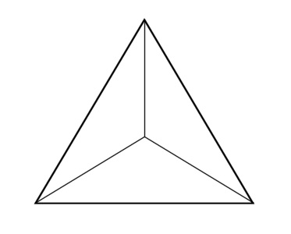
Instructions: On this page, you will label and define each area of the triangle using the three types of health that we discussed in class. Please make sure that for each section you have listed one type of health and one definition.

Now, you will look through magazines and identify three behaviors for each section of the health triangle (that means three pictures per page). You will cut these pictures from the magazines and glue them to your assignment. After you have glued your pictures, you will need to explain how each picture applies to each area of health. Please be specific and use complete sentences! If I don’t know what you’re talking about, you won’t receive credit.
Physical Health
Cut out and glue three pictures demonstrating physical health. Then, next to each picture explain in complete sentences how it can improve that area of health. If the pictures shows a negative behavior, explain how it is harming this area of health.
Mental/Emotional Health

Cut out and glue three pictures demonstrating mental/emotional health. Then, next to each picture explain in complete sentences how it can improve that area of health. If the pictures shows a negative behavior, explain how it is harming this area of health.

Social Health
Cut out and glue three pictures demonstrating social health. Then, next to each picture explain in complete sentences how it can improve that area of health. If the pictures shows a negative behavior, explain how it is harming this area of health.

