Step 1: Define the problem
Identify the problem at hand.
What are you being faced with?

Step 2: Explore your options

What are all of the possible choices you have?
Should I wear my blue, green, purple, orange, or black shirt?
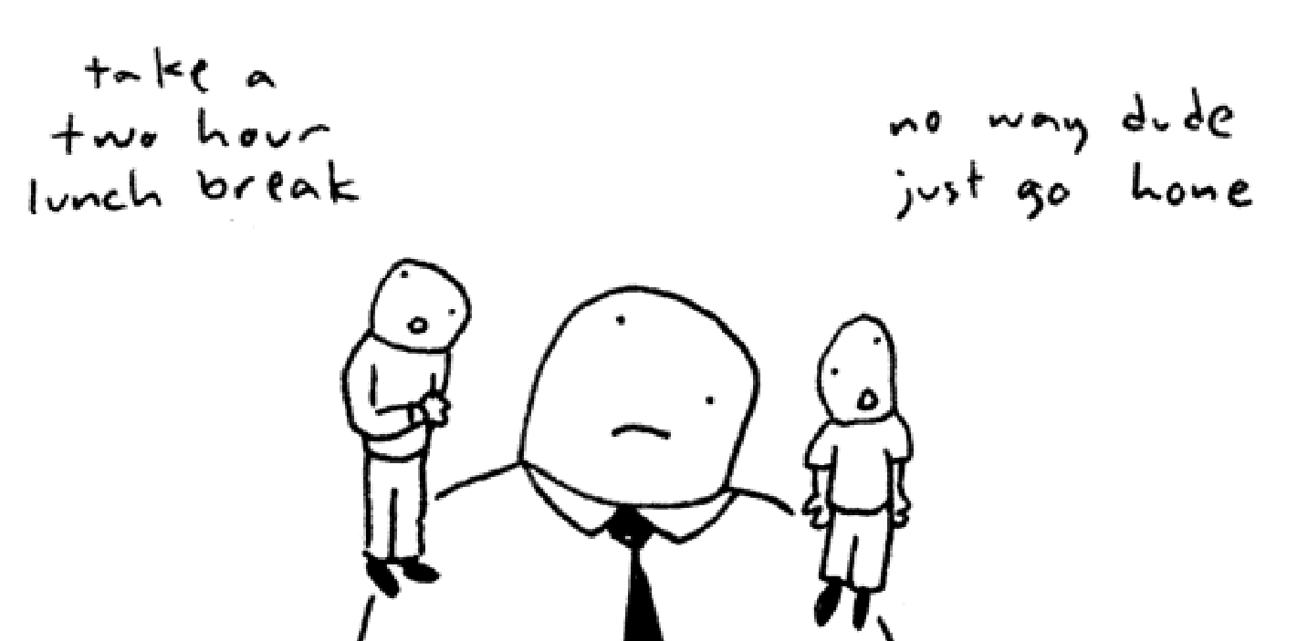
Step 3: Consider the consequences
List all of your positive and negative consequences to different choices.
There can be positive consequences to a bad choice and negative consequences to a good choice...this is what makes decision making so hard!

Step 4: Identify your values
What do you value in life that is going to influence the choice you make?
What is important to you?

Step 5: Decide & Act
Make your decision and follow through...actually do what you say you are going to do!
What will you do now?

Step 6: Evaluate the results
Do you think you’ve made the right choice?
What, if anything, could you have done differently?
What have you learned from your experience?

